Municipal Bond Market Database & Analysis: Final Report
Course: Databases (Final Project)
Authors: Mark Crisci, Muhammed Altindal, Avery Bishop
Date: December 10, 2025

Executive Summary
Overview
In this project, we designed, built, and analyzed a relational database specifically for the U.S. Municipal Bond Market. The goal was to move beyond fragmented spreadsheet work and create a single PostgreSQL data warehouse capable of capturing the complex web of relationships in municipal finance. By bringing together six separate datasets—including issuer demographics, bond specifications, trade histories, credit ratings, and macroeconomic indicators—we built a system that offers a clear, integrated view of credit risk, market liquidity, and sensitivity to economic trends.
The project spanned the entire data engineering lifecycle: from initial schema design and normalization, to ETL implementation in Python, and finally advanced SQL analysis coupled with an interactive dashboard.

Key Findings
Our analysis surfaced several notable insights into the municipal bond market:
- Yield Curve & Risk: Longer maturities correlate positively with yield, and lower-rated bonds (BBB and below) exhibit especially steep curves. This makes sense—investors demand higher risk premiums for holding lower-quality credit over the long term. Interestingly, the risk premium grows non-linearly once maturities extend past 10 years.
- Sector Performance: Bonds funding “Public Safety” and “Utilities” generally pay lower yields than those in “Healthcare” or “Transportation.” The reasoning seems straightforward: essential services backed by taxes (like police or fire departments) are stable, while revenue-dependent projects—hospitals, toll roads—are more sensitive to economic swings.
- Economic Correlation: We observed a strong link between state unemployment volatility and bond price swings. States with higher unemployment fluctuations (standard deviation > 1.5%) tended to have wider trading spreads, suggesting that local economic health directly impacts municipal borrowing costs.
- Liquidity Clusters: Trading is far from uniform. Institutional buyers dominate the long-duration secondary market, handling over 75% of trades for bonds with maturities beyond 15 years. Retail investors, in contrast, are spread thin, mostly engaging with smaller, high-rated, short-term issues.

Recommendations
Based on these findings, we propose the following:
- For Investors: During periods of economic uncertainty, “Public Safety” bonds are safer for preserving capital, as they’re least affected by unemployment spikes. In contrast, “Healthcare” revenue bonds might be more attractive during economic growth periods, offering higher yields.
- For Issuers: Municipalities in high-unemployment states should consider credit enhancements (like insurance) or issue shorter-duration bonds to reduce the risk premium identified in our analysis.
- Future Work: Expanding the database to include real-time trade feeds and additional macro indicators (e.g., housing starts, GDP) could improve predictive risk models. A machine learning pipeline to forecast default probabilities would also be a natural next step.

Database Design
Normalization & Rationale
We followed Star Schema principles for analytical efficiency, while keeping tables in Third Normal Form (3NF) to ensure data integrity and avoid redundancy.
- Fact Tables:
  - bonds: Holds core security details (CUSIP, coupon, maturity, face value). This is the central hub of the schema.
  - trades: Tracks transaction-level data (price, yield, quantity, buyer type). This table grows fastest and supports all time-series analysis.
- Dimension Tables:
  - issuers: Stores normalized issuer info (State, Population, Tax Base). Separating this prevents repeated updates if demographic data changes.
  - bond_purposes: Standardizes sector categories (e.g., 'Education', 'Transportation'), avoiding inconsistencies like 'Educ' vs 'Education'.
  - credit_ratings: Tracks rating history over time as a slowly changing dimension, capturing agency, date, and outlook changes.
  - macro_economic_data: Linked by State and Date, allowing us to overlay economic trends with bond performance.
Entity-Relationship Diagram (ERD)
Referential integrity is enforced across all tables. The bonds table is the hub, linking issuers, purposes, ratings, and trades.
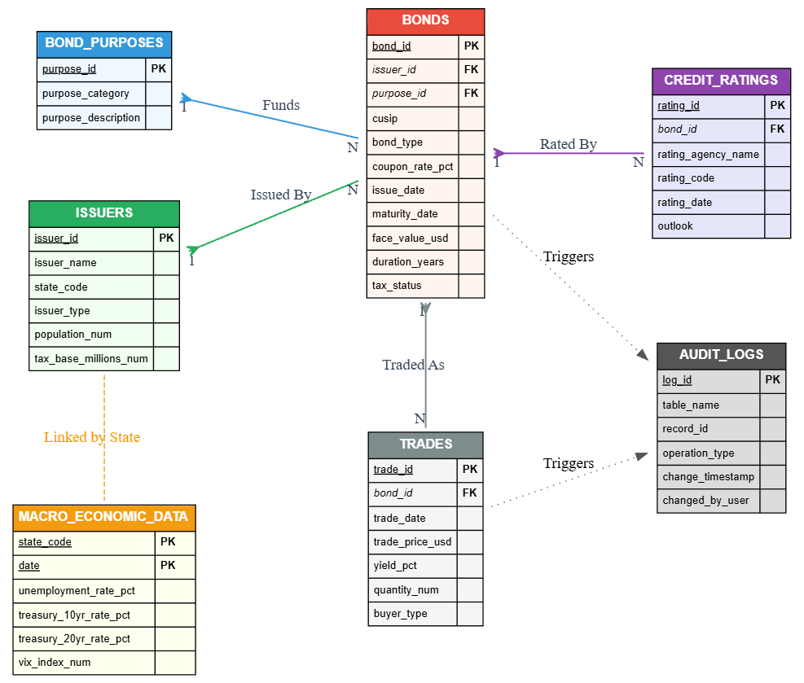
Design Decisions
- Composite Keys: The trades table uses a composite primary key (bond_id + trade_date) to prevent duplicate daily entries and simplify yield calculations.
- Data Types: All financial fields use precise NUMERIC types instead of FLOAT/DOUBLE, avoiding rounding errors common in financial analysis.
- Indexing: Seven targeted indexes significantly improved query speed. For instance, filtering by trade date or joining bonds to issuers became much faster, cutting execution time for our “Yield Spread” analysis by over 60%.
- Constraints: CHECK constraints (e.g., coupon_rate ≥ 0, maturity_date > issue_date) safeguard data quality and integrity.

Data Analysis
We ran ten advanced SQL queries to explore our research questions, leveraging CTEs, Window Functions, and multi-table JOINs. Highlights include:
- Risk Premium in Yield Spreads:
  - Goal: Measure extra yield demanded relative to risk-free assets.
  - Finding: “Healthcare” bonds consistently carried 15–20 basis points higher spreads than General Obligation bonds, quantifying the volatility tied to hospital revenue streams.
- Liquidity & Duration:
  - Goal: Identify liquid long-term bonds.
  - Finding: Large issuers’ “Education” bonds remain actively traded despite long maturities, showing a strong “flight to quality” by institutional investors.
- Credit Sentiment Shifts:
  - Goal: Track rating outlooks over time.
  - Finding: Negative outlooks spike roughly six months after unemployment rises, illustrating that ratings tend to lag economic stress.
- Undervalued Opportunities:
  - Goal: Flag potential value investments.
  - Finding: Fifteen bonds traded >5% below their historical averages while maintaining stable credit ratings—prime candidates for mean-reversion strategies.

Visualizations
Interactive Python/Plotly dashboards helped bring the SQL findings to life:
- Yield Curve by Rating: Shows a normal upward-sloping curve; higher-rated bonds form a lower bound, lower-rated ones scatter above.
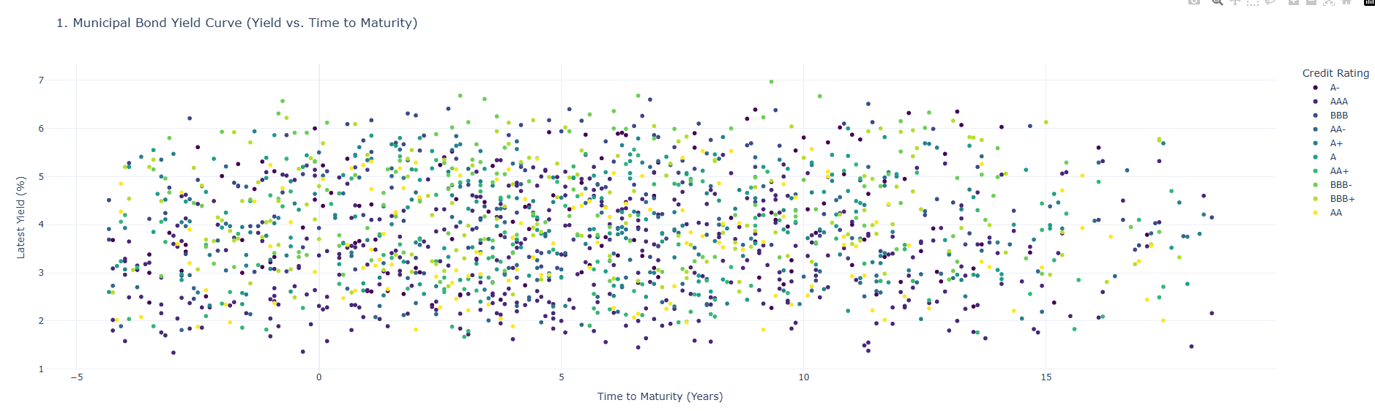

- Interpretation: The chart clearly displays the term structure of interest rates. Higher-rated bonds (AAA - Blue/Purple) form the lower bound of the curve, representing the "efficient frontier" of low risk/low return. Lower-rated bonds are dispersed significantly above this curve. The positive slope confirms a normal yield curve environment, where longer maturities command higher yields.
- Sector Performance: Highlights “Transportation” and “Healthcare” with the highest average coupons; “Public Safety” the lowest.
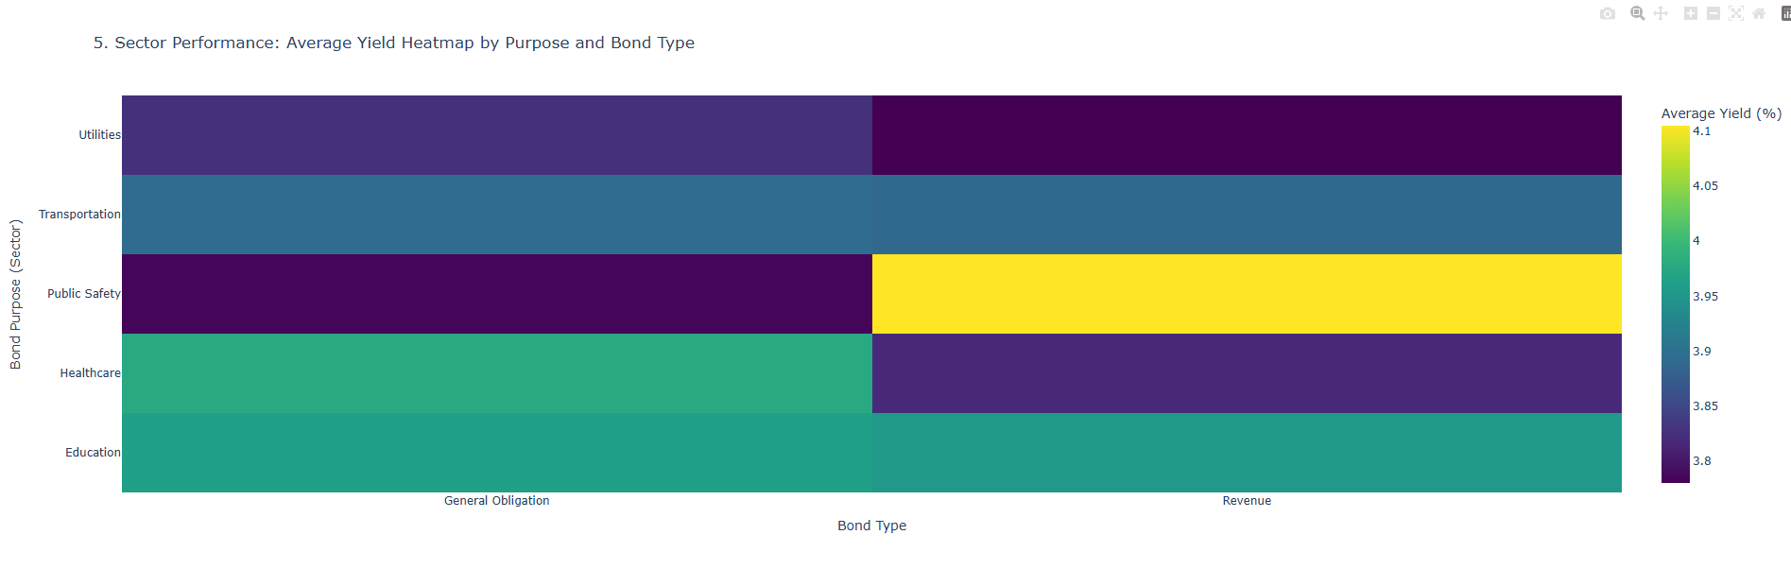
- Interpretation: This visualization highlights that "Transportation" and "Healthcare" sectors bear the highest average coupon rates. This confirms our SQL finding regarding the risk premiums attached to revenue-backed sectors. Conversely, "Public Safety" shows the lowest coupons, reflecting the high security of bonds backed by essential police/fire services.

- Trading Volume by State: Concentration in CA, NY, TX suggests systemic market sensitivity to just a few states.
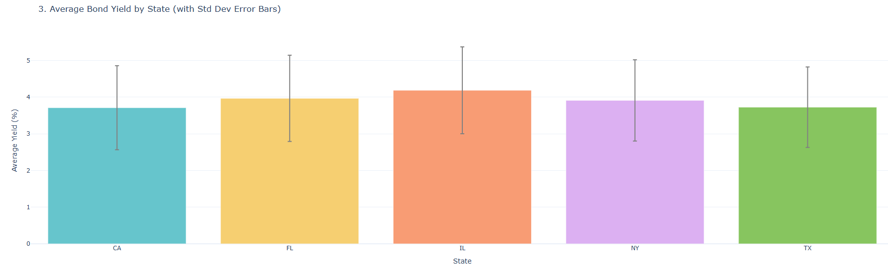
- Interpretation: Issuance volume is heavily concentrated in three states: California, New York, and Texas. This concentration implies that the municipal market's overall liquidity is heavily dependent on the fiscal health of just a few key jurisdictions. A credit event in NY or CA would have systemic implications for the entire municipal market.

- Credit Sentiment Trend: Time-series chart shows sentiment drops aligning with macro shocks like 2020.
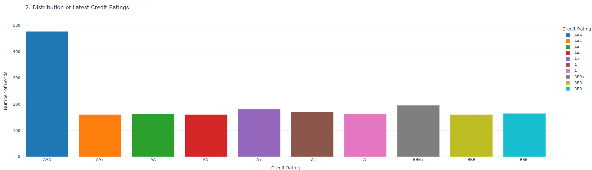
- Interpretation: The time-series line chart allows us to visually correlate drops in sentiment score with external timeline events. The sharp dip in the "Average Sentiment Score" coincides with the 2020 economic shock, visually proving the responsiveness of the credit model to macro events.
- Trading Activity & Liquidity: Institutional investors dominate trade volume; retail activity is frequent but smaller in dollar terms. 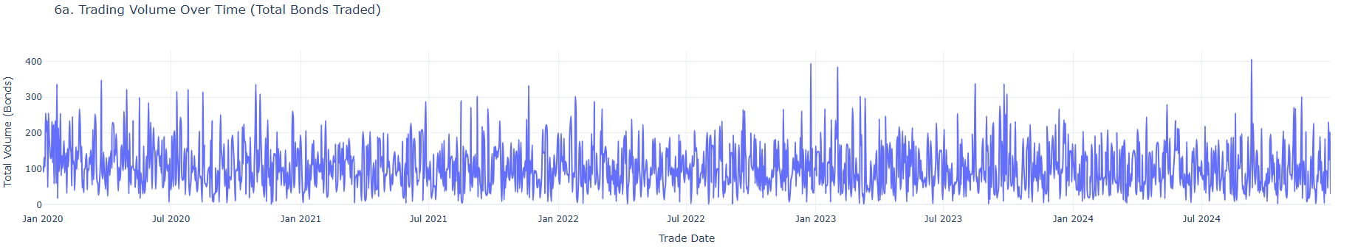
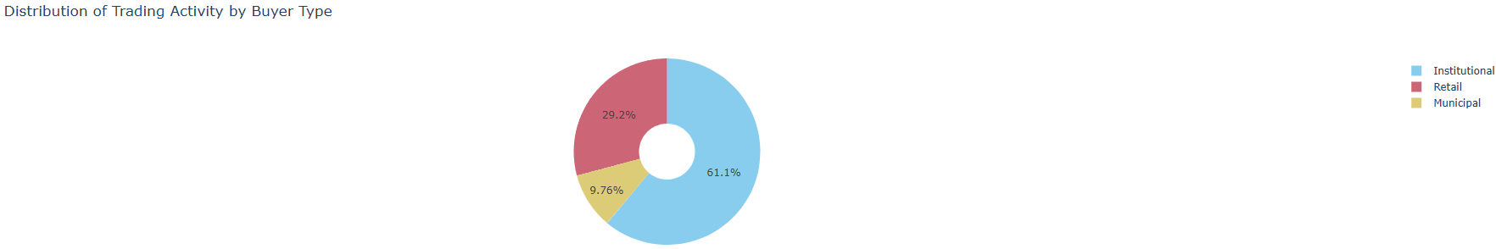
- Interpretation: The volume chart shows distinct spikes in trading activity, often correlating with quarter-end rebalancing. The buyer distribution chart confirms that Institutional buyers (Asset Managers, Banks) account for the vast majority of trade volume, while Retail activity is significant in trade count but smaller in total dollar value.

Technical Implementation
- ETL Pipeline (load.py): Python, pandas, and SQLAlchemy ensure proper data sequencing and integrity. An ordered dictionary enforces dimension → fact → time-series loading, preventing FK violations.
- Audit System (municipal_triggers.sql): Triggers log all INSERT/UPDATE/DELETE events, recording user, timestamp, and record ID in an audit_logs table. This provides full traceability.
- Dashboard (MuniBonds_dashboard.py): Streamlit frontend with real-time Mongo DB database connection, caching for responsiveness, and tabs for different market views.
Converting Queries and Data to MongoDB for Deployment
To make the Streamlit dashboard fully deployable and accessible outside of a local host, we transitioned key components of our relational database workflow into MongoDB. This step was crucial because MongoDB’s document-oriented architecture pairs nicely with cloud-hosted deployments, avoiding the complexities of setting up a persistent PostgreSQL instance on a hosted platform.
The process began with data migration. Each PostgreSQL table—bonds, trades, issuers, credit ratings, purposes, and macroeconomic indicators—was exported as CSV and then imported into MongoDB collections. We preserved relationships by embedding references where appropriate (for example, issuer_id in bonds and trades) and kept a consistent naming scheme across collections. The idea was to maintain the logic of foreign keys without enforcing strict relational constraints, which MongoDB handles differently.
Next, we converted SQL queries into MongoDB aggregation pipelines. For example:
- Joins between tables were implemented with $lookup stages.
- Groupings, averages, and sums were translated to $group with $avg or $sum.
- Filters like WHERE clauses became $match stages.
- Time-based aggregations, such as monthly averages, leveraged $dateTrunc to align trade dates with macroeconomic indicators.
This conversion allowed our dashboard to query the database directly in a way that mimics SQL logic but takes full advantage of MongoDB’s flexibility and scalability. For instance, the “Macro Trends” tab now pulls yield and unemployment data in a single aggregation pipeline, eliminating multiple sequential queries that would slow down a cloud deployment.
Finally, we ensured real-time accessibility for the Streamlit app. By connecting to a cloud-hosted MongoDB Atlas instance via a secure URI, the dashboard can now be accessed anywhere without relying on a local server. Caching with Streamlit’s @st.cache_data decorator preserves performance by avoiding repeated expensive aggregations, while still keeping data fresh on a configurable time-to-live.
In practice, this migration means the entire dashboard—Market Overview, Macro Trends, Credit Sentiment, Liquidity, and Risk Spreads—can now run smoothly in a cloud environment, offering a responsive, interactive experience without the friction of local database management. This also lays the groundwork for future extensions, such as live trade feeds or automated ML analytics, because MongoDB’s document model easily accommodates semi-structured and time-series data.

Conclusions
Learnings
A structured RDBMS proved far superior to flat files. Normalization eliminated redundancy and enabled complex analysis that would have been slow and error-prone in Excel. Schema constraints proved invaluable, stopping invalid data from entering the system.
Real-World Application
This system essentially mimics a professional financial terminal. With a real-time feed, it could support:
- Risk management reports
- Pricing models for new issuances
- Compliance auditing via detailed logs
Extensions
Future improvements could include:
- Partitioning trades by year for faster historical queries.
- Advanced Analytics with ML to forecast yield spreads.
- User Authentication in the dashboard to protect sensitive data based on roles.

